# PROJECT ON: Lockedme.com

**Project Submitted in Partial Fulfillment of the Requirements for the Course of full stack development**

#### Submitted by

**Mayank Kumar**

**E-mail: mayank.3900.mk@gmail.com**

# Under the guidance of Deepak Sir



Acknowledgement

Acknowledgement is just a way to show the gratitude towards those Person who had helped in completing the system.

We are extremely grateful and remain indebted to our mentor **DEEPAK SIR** for being a source of inspiration and for his constant support in the completion of the project. We would like to thankful them for their constant constructive criticism and precious suggestions, which benefited us a lot while developing the project on Lockedme.com. He has been a constant source of inspiration and motivation for hard work. He has been very co-operative throughout this project work.

Through this column, it would be our extreme pleasure to express our warm thanks to her for their encouragement, co-operation and consent without which we might not be able to accomplish this project.

Finally, we would like to express thanks to my friends and faculties who had put their belief and help me in every critical situation for completion of project on time and also discussed my Problem Every time when I was in trouble.

Thank you all.

|  |  |  |
| --- | --- | --- |
| **Sr. No** | **Contents** | **Page No.** |
| 1. | **Flowchart of the project** | **4** |
| **2.** | **Goal of the Project** | **5** |
| **3.** | **User story** | **6** |
| **4.** | **Sprint** | **7-8** |
| **4.** | **Project objective and background of the statement** | **9** |
| **5.** | **Technology used and requirements** | **10** |
| **6.** | **Features of the project** | **11** |
| **7.** | **Function of the project** | **12** |
| **8.** | **Screenshots** | **13-15** |

**Flowchart of the project**

Display options and Developer Details

3.Delete a file

2.Add a file

2.Display file name and and exists

1 Write file name to search

2.file deleted and exit

1.Write file name to delete

4.Search a file

4.Exit

3.Write text in each line

2.Enter no. of lines

1.write down name of file

LOCKEDME

1.Display all files

5.Exit Program

Goal of the project

The aim of this project to digitize their products and chose LockedMe.com as their first project to start with. The prototype of the application will be then presented to the relevant stakeholders for the budget approval.

The goal of the company is to deliver a high-end quality product as early as possible.

**USER STORY**

**TASK 1 -** Setting up Git and GitHub account

**TASK 2 -** Coding part of project appearance, and user interactions

**TASK 3 -** Generic features and three operations:

* + Retrieving the file names in an ascending order
  + Business-level operations:
    - Option to add a user specified file to the application
    - Option to delete a user specified file from the application
    - Option to search a user specified file from the application
    - Navigation option to close the current execution context and return to the main context
  + Option to close the application

**TASK 4 –** write up the Specification document .

**TASK 5**- complete the project and submit to the github account.

**Sprint**

**Day1: Task 1 it is completed.**

**Task2 Partially completed.**

**Task3 not started yet.**

**Task4 Partially completed.**

**Task5 not started yet.**

**Day2: Task 1 it is completed.**

**Task2 it is completed.**

**Task3 Partially completed.**

**Task4 Partially completed.**

**Task5 it is not completed.**

**Day3: Task 1 it is completed.**

**Task2 it is completed.**

**Task3 Partially completed.**

**Task4 Partially completed.**

**Task5 it is not completed.**

**Day4: Task 1 it is completed.**

**Task2 it is completed.**

**Task3 Partially completed.**

**Task4 Partially completed.**

**Task5 it is not completed.**

**Day5: Task 1 it is completed.**

**Task2 it is completed.**

**Task3 it is completed.**

**Task4 Partially completed**

**Task5 it is not completed.**

**Day6: Task 1 it is completed.**

**Task2 it is completed.**

**Task3 it is completed.**

**Task4 it is completed.**

**Task5 it is not completed.**

**Day7: Task 1 it is completed.**

**Task2 it is completed.**

**Task3 it is completed.**

**Task4 it is completed.**

**Task5 it is completed**

**Project objective:**

As a Full Stack Developer, complete the features of the application by planning the development in terms of sprints and then push the source code to the GitHub repository. As this is a prototyped application, the user interaction will be via a command line.

**Background of the problem statement:**

Company Lockers Pvt. Ltd. hired you as a Full Stack Developer. They aim to digitize their products and chose LockedMe.com as their first project to start with. You’re asked to develop a prototype of the application. The prototype of the application will be then presented to the relevant stakeholders for the budget approval. Your manager has set up a meeting where you’re asked to present the following in the next 15 working days (3 weeks):

* Specification document - Product’s capabilities, appearance, and user interactions
* Number and duration of sprints required
* Setting up Git and GitHub account to store and track your enhancements of the prototype
* Java concepts being used in the project
* Data Structures where sorting and searching techniques are used.
* Generic features and three operations:
* Retrieving the file names in an ascending order
* Business-level operations:
* Option to add a user specified file to the application
* Option to delete a user specified file from the application
* Option to search a user specified file from the application
* Navigation option to close the current execution context and return to the main context
* Option to close the application

**Technology used:**

* Eclipse/IntelliJ: An IDE to code for the application
* Java: A programming language to develop the prototype
* Git: To connect and push files from the local system to GitHub
* GitHub: To store the application code and track its versions
* Scrum: An efficient agile framework to deliver the product incrementally
* Search and Sort techniques: Data structures used for the project
* Specification document: Any open-source document or Google Docs

**Requirements:**

* The source code should be pushed to your GitHub repository. You need to document the steps and write the algorithms in it.
* The submission of your GitHub repository link is mandatory. In order to track your task, you need to share the link of the repository. You can add a section in your document.
* Document the step-by-step process starting from sprint planning to the product release.
* Application should not close, exit, or throw an exception if the user specifies an invalid input.
* You need to submit the final specification document which includes:
  + Project and developer details
  + Sprints planned and the tasks achieved in them
  + Algorithms and flowcharts of the application
  + Core concepts used in the project
  + Links to the GitHub repository to verify the project completion
  + Your conclusion on enhancing the application and defining the USPs (Unique Selling Points)

### Features of the Project

* Code to display the welcome screen. It should display:
  + Application name and the developer details
  + The details of the user interface such as options displaying the user interaction information
  + Features to accept the user input to select one of the options listed
* The first option should return the current file names in ascending order. The root directory can be either empty or contain few files or folders in it
* The second option should return the details of the user interface such as options displaying the following:
  + Add a file to the existing directory list
    - You can ignore the case sensitivity of the file names
  + Delete a user specified file from the existing directory list
    - You can add the case sensitivity on the file name in order to ensure that the right file is deleted from the directory list
    - Return a message if FNF (File not found)
  + Search a user specified file from the main directory
    - You can add the case sensitivity on the file name to retrieve the correct file
    - Display the result upon successful operation
    - Display the result upon unsuccessful operation
  + Option to navigate back to the main context
* There should be a third option to close the application

### functionality

Generic features and three operations:

* Retrieving the file names in an ascending order
* Business-level operations:
  + Option to add a user specified file to the application
  + Option to delete a user specified file from the application
  + Option to search a user specified file from the application
  + Navigation option to close the current execution context and return to the main context
* Option to close the application

**Screenshot of Output**

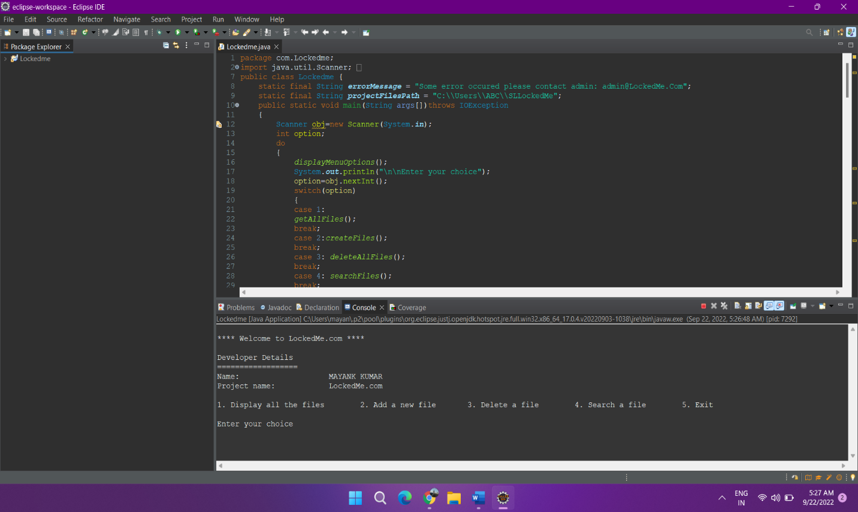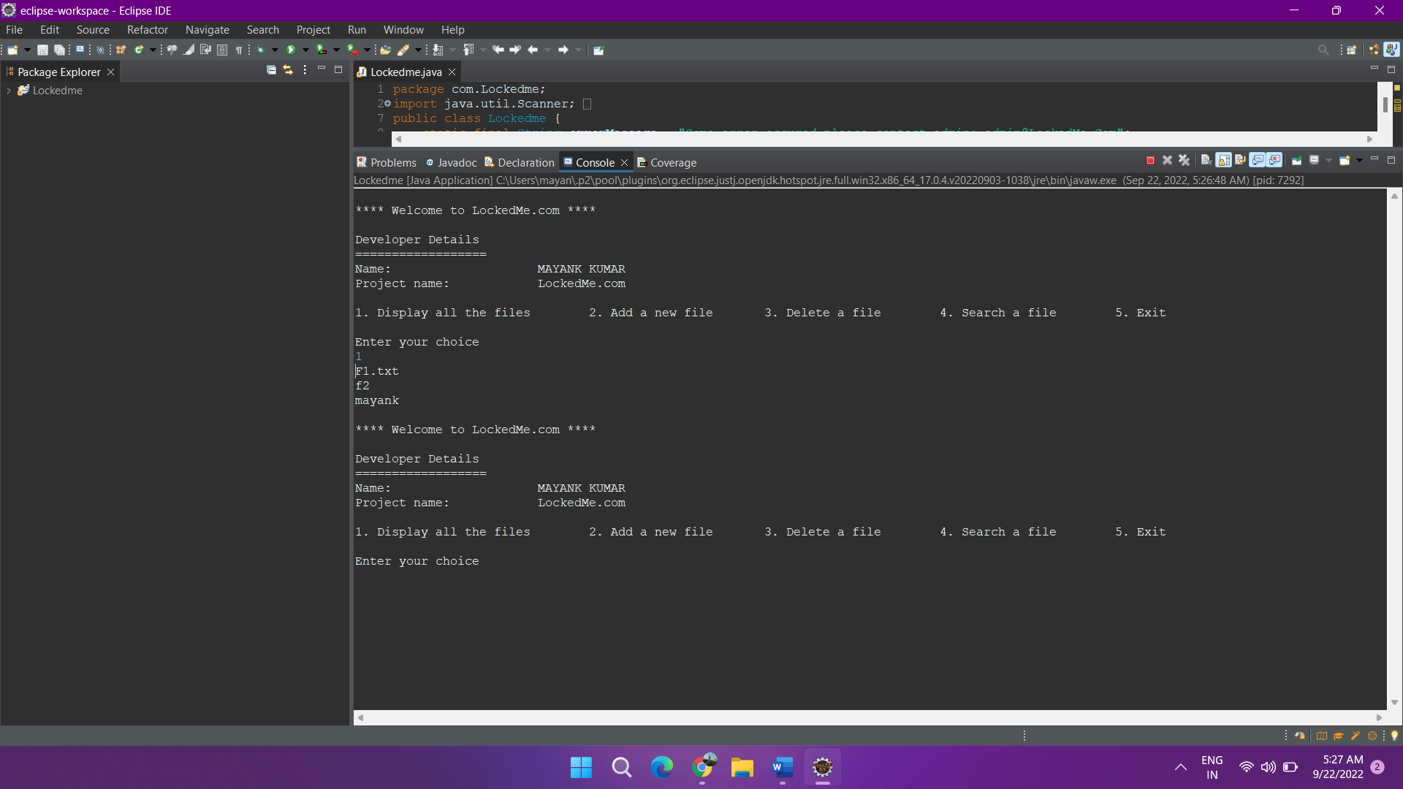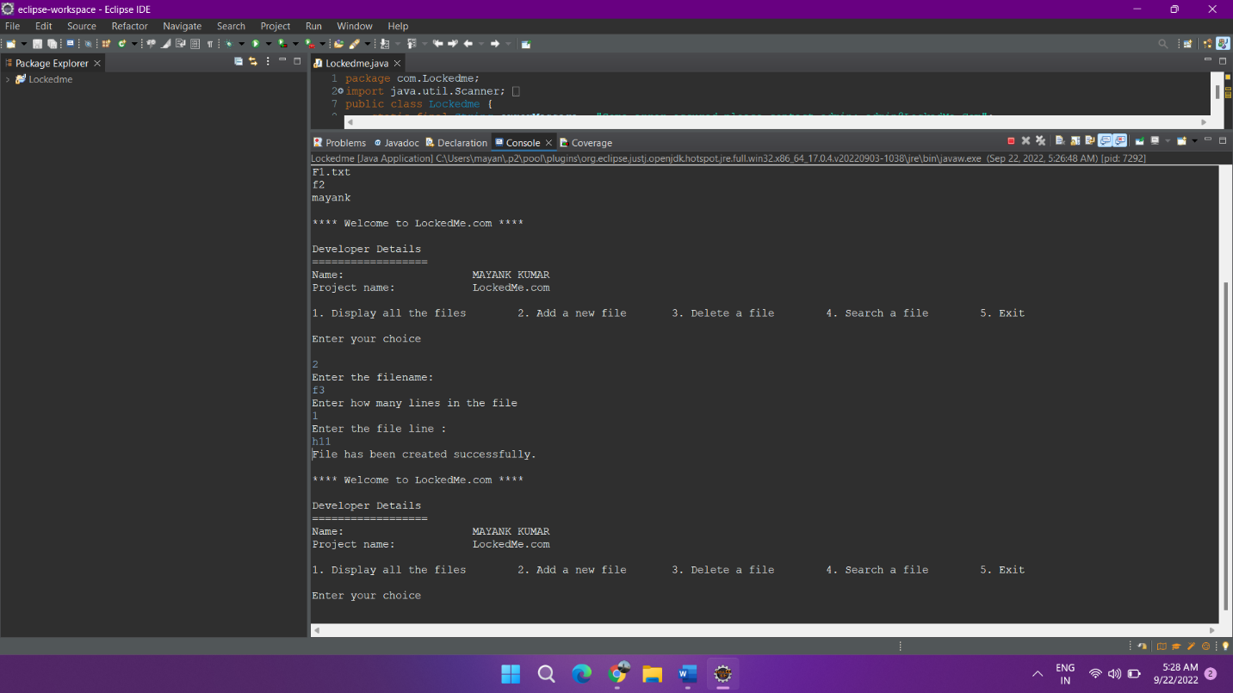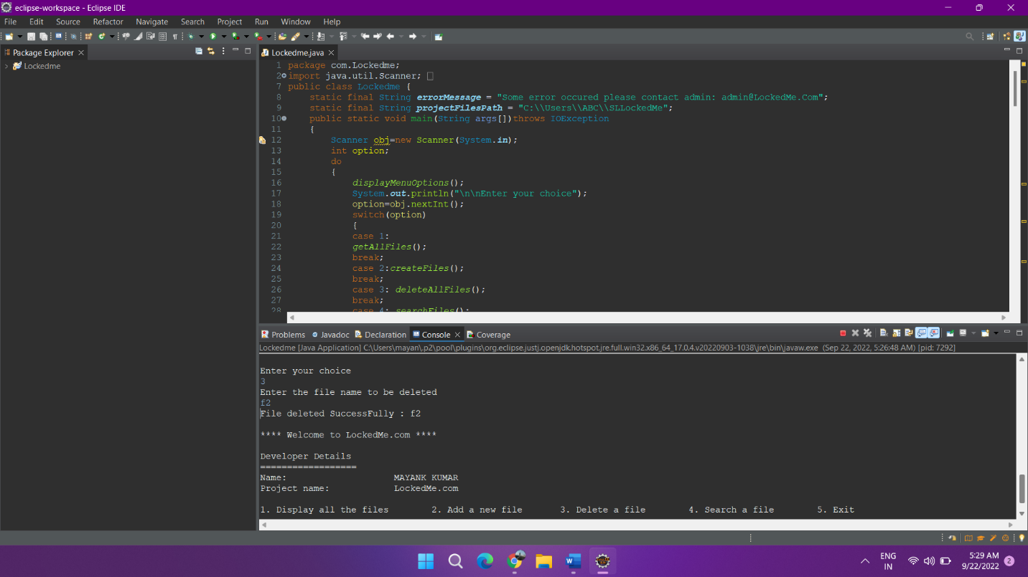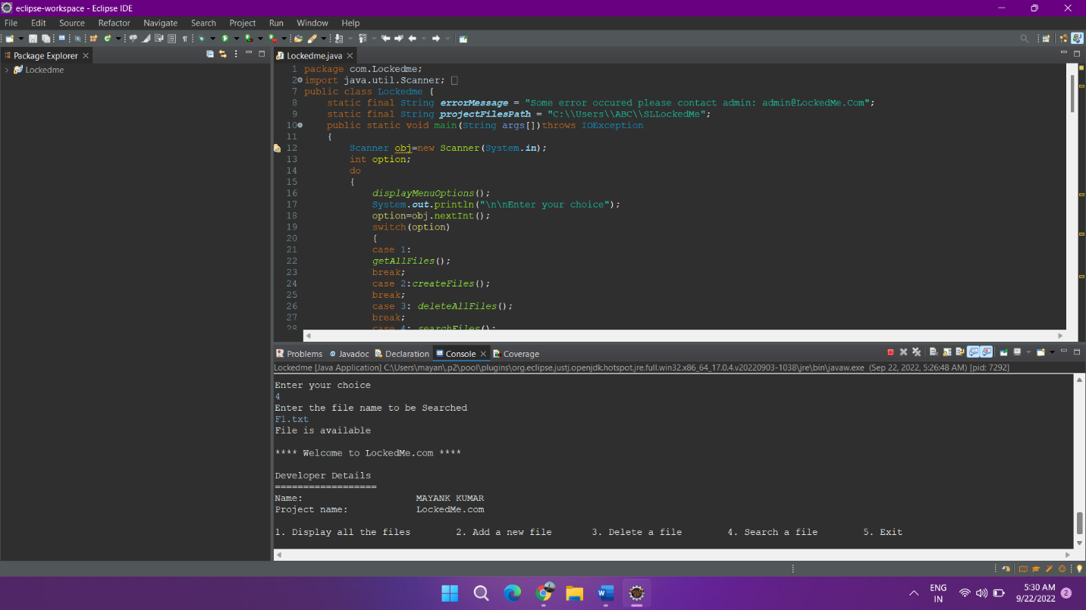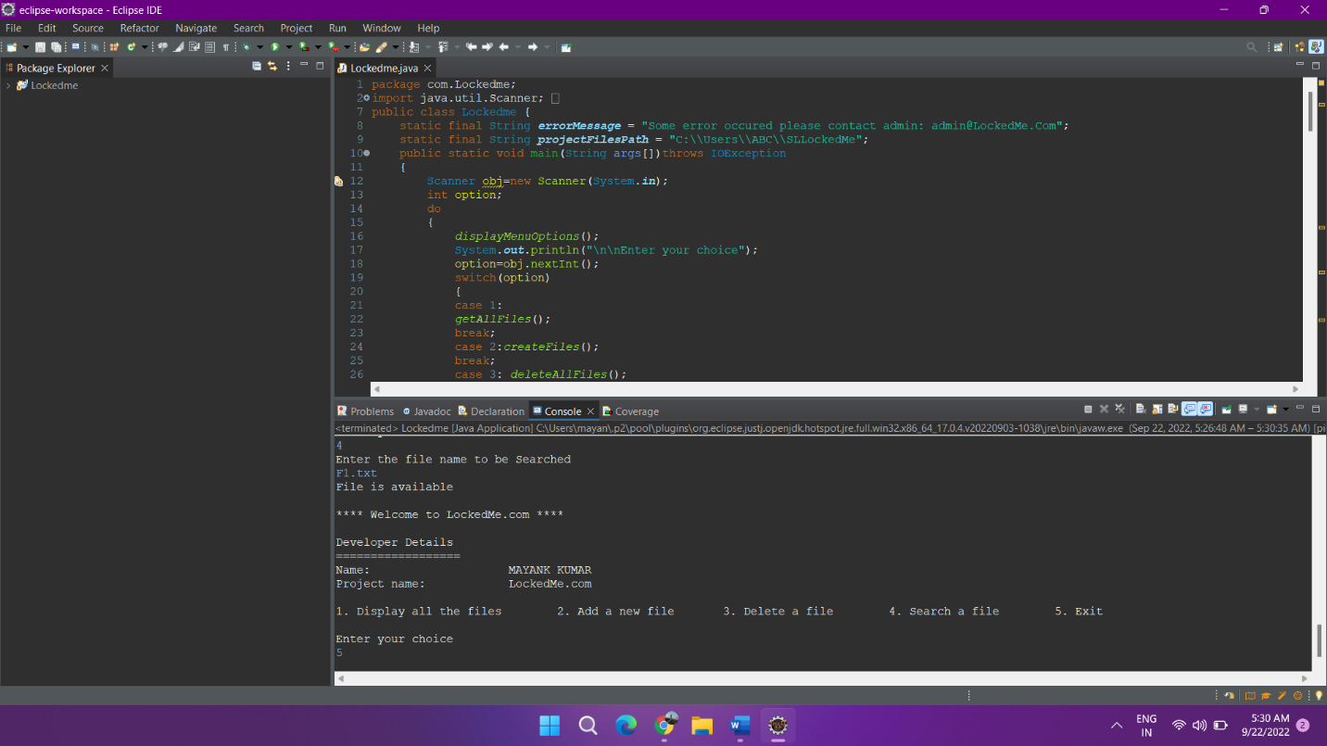

##### END